**Visualization of GDP and Life Expectancy of Countries**

Initially, I have taken a data set of 5 countries’ namely ANGOLA, BRAZIL, CAMEROON, DUBAI, ETHIOPIA.

And successfully loaded them to Rstudio.



after loading of data, I installed the required packages for the scattershot.

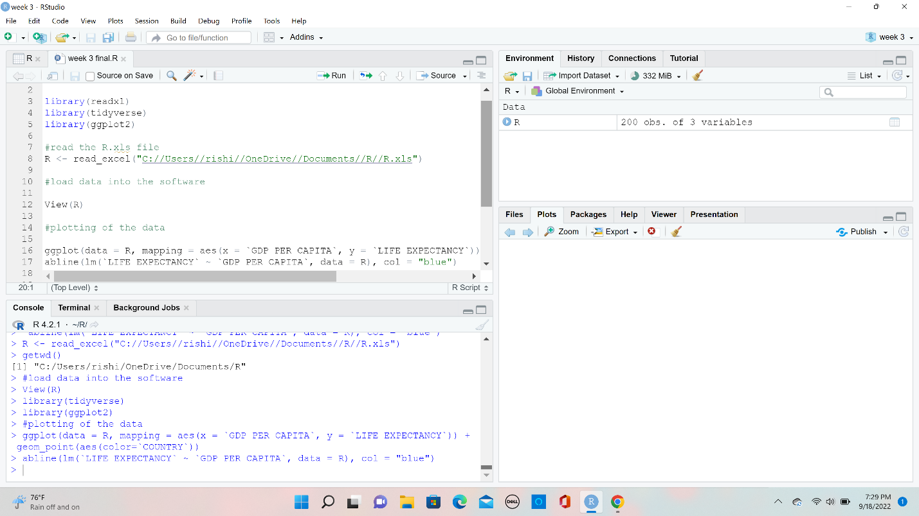

After that created a path to “R” by using “Set Work Directory” in session. Now that all the base work is set written commands in R to load data and set a plot.

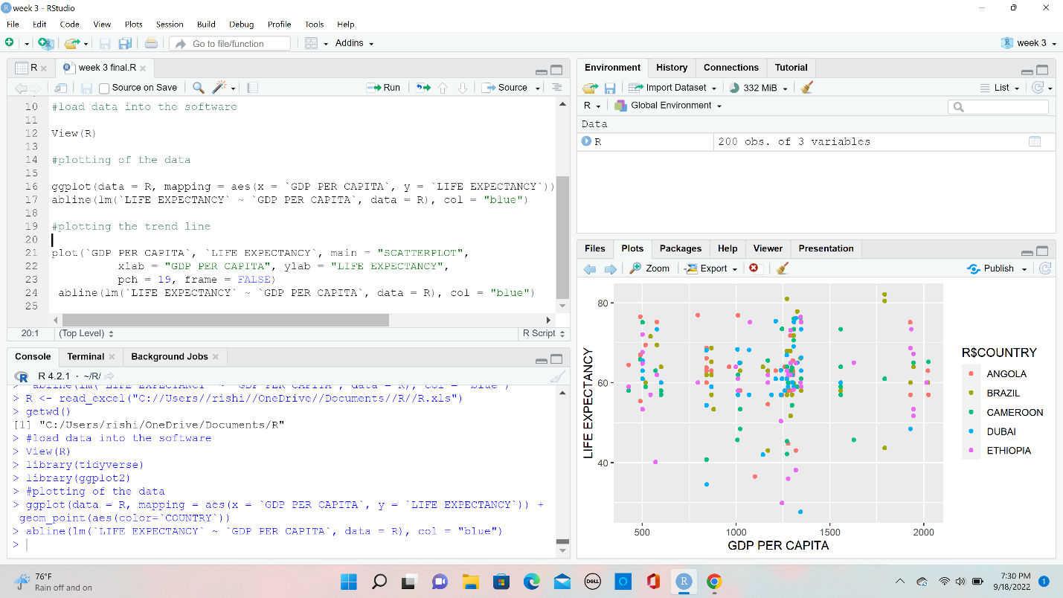

I began plotting the data using ggplot, geom_point, and aesthetics.

#plotting the trend line.

Life Expectancy vs GDP per Capita summary

The scatterplot above shows the distribution of life expectancy against GDP per capita in five countries. Here, we are trying to find how GDP per capita has affected Life Expectancy in those countries. As shown by the figure, most life expectancy lies between 60 to 70 years. Very few people in these countries are dying at the age of below 40 years and above 80 years. Brazil has the highest life expectancy of about between 43 years and 84 years. Dubai has the lowest point in life expectancy of about 7 years.

There is a significance increase in life expectancy as GDP per capita is increasing. This shows that the death rates have gone down and people are living for more years as a result if good life standards. The contrary is true for low GDP per capita. The lowest GDP per capita was about 450 while the highest in these counties is 2000.